REVISED WIREFRAME SUMMARY

Desktop Wireframe - Improvements Modifications:
User access via the Navigation Bar was improved by including a constant login/signup button.
Search Bar: Added placeholder text and shifted it a bit left for visual hierarchy.
Categories: For faster identification, added symbols beside category names.
Converted to a carousel style to highlight several guides or promotions.
Why Sell Section: Transformed into a 3-column layout with icons and brief text for visual balance.
Trust emblem: Included a tooltip for security guarantee under a visible "Verified Seller" emblem.
Reasons for Development:
Provides greater visual signals, hence increasing usability.
Improves involvement by means of icon utilisation and carousels.
Clearer CTAs and login visibility help to raise conversion potential.

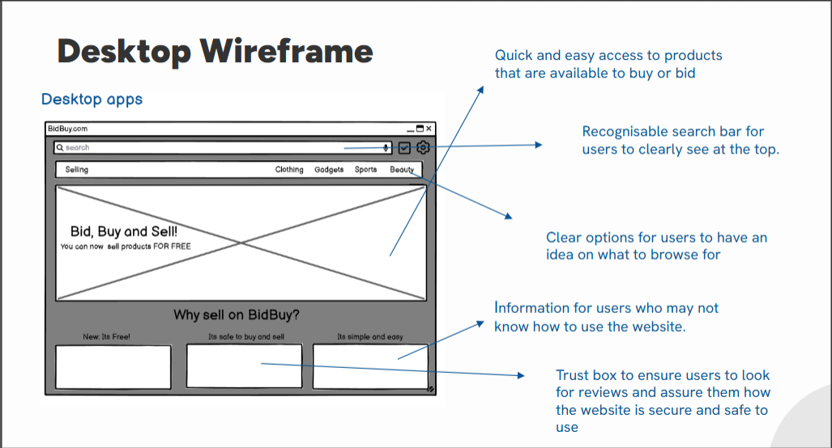

Mobile Wireframe - Improvements Alterations:
Search Bar: Included a microphone symbol in the search box to harmonise the interface.
Navigation Bar: Increased bottom nav icon size and included labels (e.g., Home, Categories, Sell, Cart, Account).
Categories Section: Swapped squares for horizontally scrollable category chips (e.g., "Gadgets," "Beauty").
Recommended for You: Included heart or star symbols for fast wishlist activity.
Customised Card: To save user choice time, included a brief summary and "Buy Now" button.
Reasons for Development:
Improves mobile ergonomics which is crucial for thumb-friendly engagement.
Simplified design and actions let users browse faster.
Extra buttons/icons help to make personalisation more practical.

